Nathaniel Murphy

Lab 2

**Screenshot**

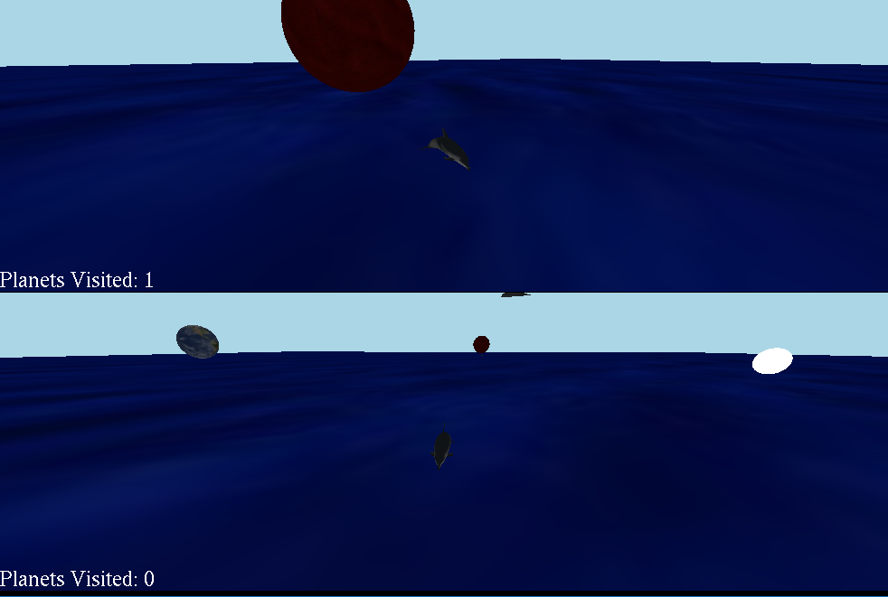

**How to Compile and Run**

Batch files are in the folder to make it easier to compile and run. In the command line run the compile.bat and then the run.bat in order to play.

**How to play**

* Race to visit the most planets before the other player.
* Gain a point for each planet visited first.

**Top Player – Xbox Controller**

|  |  |
| --- | --- |
| Y, X, A, B | Forward/Left/Backward/Right |
| LB, RB | Turn Left/Right |
| Left Joystick | Move camera In/Out |
| Right Joystick | Move camera Around Dolphin |

**Bottom player - Keyboard**

|  |  |
| --- | --- |
| W, A, S, D | Forward/Left/Backward/Right |
| Q, E | Turn Left/Right |
| Arrow Up and Down | Move camera Up/Down |
| Arrow Left and Right | Move camera Left/Right |
| X, Z | Zoom In/Out |

**Node Controllers**

There is a node controller for each play that adds either a spin to the planet or starts to move the planet up and down.

**Hierarchical Relationship**

There is a solar system node that gets a controller applied to it once all the planets have been visited. It causes al the planets to orbit around the center of the world.

Also the light nodes are children of the dolphin nodes.

**Camera**

The camera controls are made to be an orbit camera.

**Assets Used**

dolphinHighPoly.obj – from the dolphin click game.

Earth.obj – from the dolphin click game.

Planet2/3.obj – made from the earth.obj.

Red.jpeg - from the dolphin click game.

Moon.jpeg – from the dolphin click game.

Hexagons.jpeg – from the dolphin click game.

Blue.jpeg – from the dolphin click game.